**DAILY ONLINE ACTIVITIES SUMMARY**

|  |  |  |  |  |  |  |  |  |
| --- | --- | --- | --- | --- | --- | --- | --- | --- |
| **Date:** | **29/06/2020** | | | | | **Name:** | **NIKHIL KUMAR** | |
| **Sem & Sec** | **4thSEM. & ‘B’ SEC.** | | | | | **USN:** | **4AL19CS400** | |
| **Online Test Summary** | | | | | | | | |
| **Subject** | | **DATA COMMUNICATION** | | | | | | |
| **Max. Marks** | | **30** | | **Score** | | | **27** | |
| **Certification Course Summary** | | | | | | | | |
| **Course** | **SQL and Relational Databases 101** | | | | | | | |
| **Certificate Provider** | | | **Cognitive class** | | **Duration** | | | **5hr** |
| **Coding Challenges** | | | | | | | | |
| **Problem Statement1 :**  Given a list of numbers, write a Python program to count Even and Odd numbers in a List.  Example: Input: list1 = [2, 7, 5, 64, 14] Output: Even = 3, odd = 2 Input: list2 = [12, 14, 95, 3] Output: Even = 2, odd = 2 Example 1: count Even and Odd numbers from given list using for loop Iterate each element in the list using for loop and check if num % 2 == 0, the condition to check even numbers. If the condition satisfies, then increase even count else increase odd count. | | | | | | | | |
| **Status: Executed** | | | | | | | | |
| **Uploaded the report in Github** | | | | | **Yes** | | | |
| **If yes Repository name** | | | | | <https://github.com/Nikhil401/C-Coding/blob/master/OddEven.py> | | | |
| **Uploaded the report in slack** | | | | | **Yes** | | | |

**Online Test Summary : NULL**

**Certification Course Summary: Today I have gone through the module4 which includes sorting resulting sets, grouping result sets and all**

**Snapshot is given below**

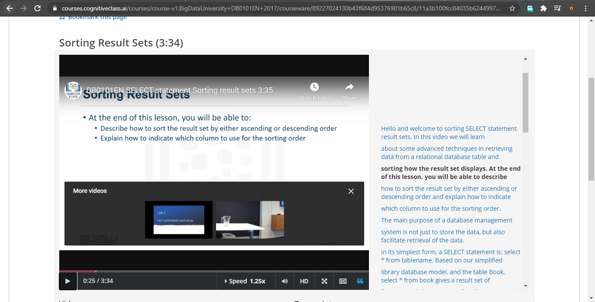

**Online Training : Today I had attended the online training organized by CSE Department AIET. The training was on Cyber Security and Features done by prof. Manjunath kotari HOD of CSE Dept. After the session the quiz was conducted.**

**And the snapshot is given below**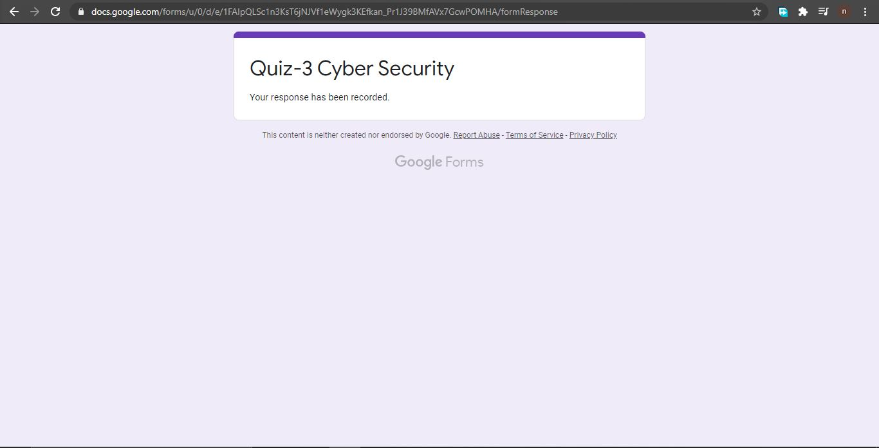

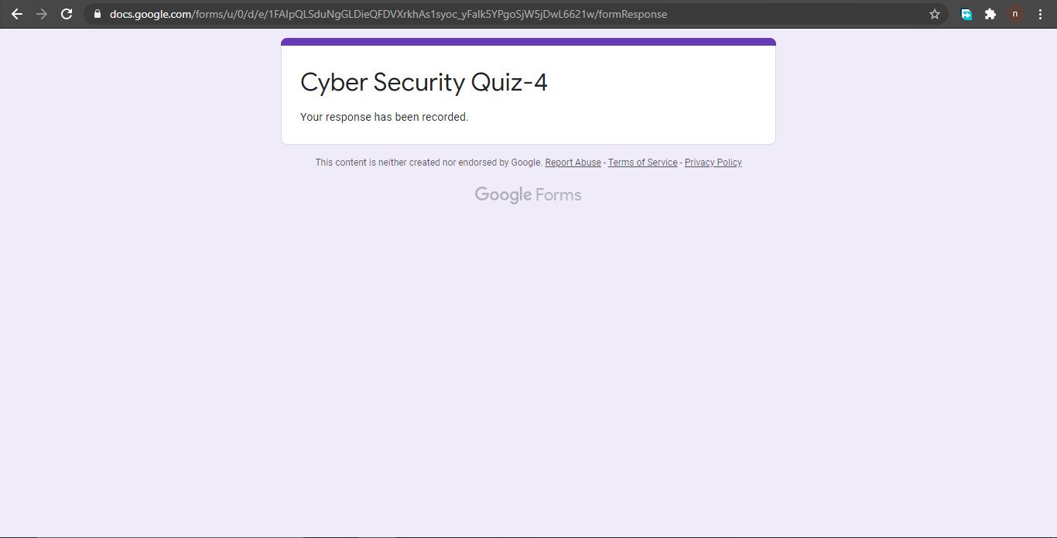

**Online coding summary: Today I had received one program which is mentioned in table above and I have uploaded into the github repository. Snapshot of the program is given below: 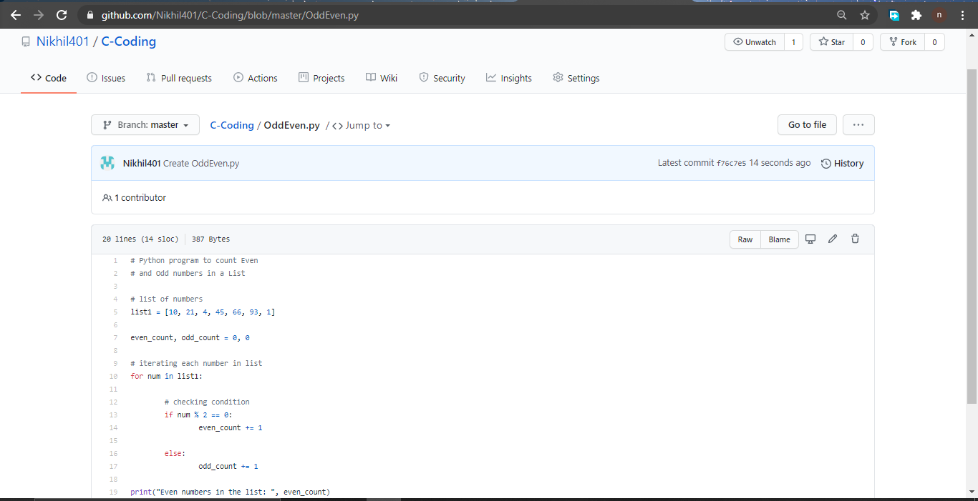 Thank you.**